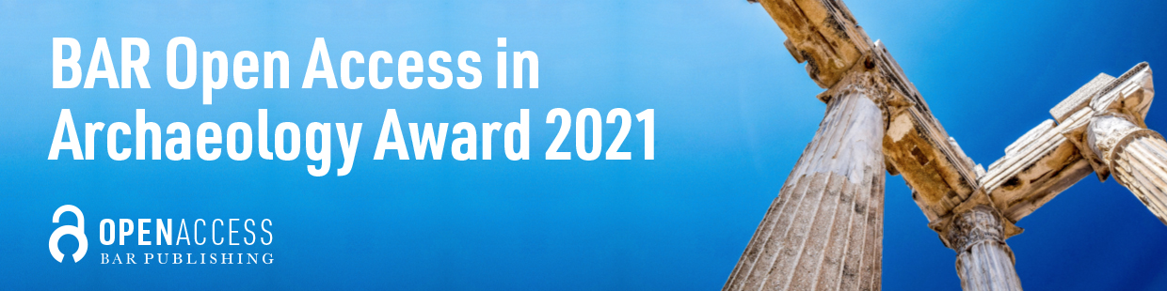
Entry Form

We are delighted that you are entering your project for consideration for the BAR Open Access in Archaeology Award, celebrating innovation and excellence in archaeological research.

Please send the following documents by email to award@barpublishing.com
- completed form
- CV
- draft chapter or other sample material (up to 7000 words)
- table of contents & brief chapter outline

For the email subject line please use your surname, first name, title of your work
e.g. SMITH, Jane: An Introduction to Archaeological Practice

Author/Editor Information

☐ I agree to the Terms and Conditions

Name(s) | Click or tap here to enter text.
For volumes with multiple contributors, please provide their names & confirm that they have agreed to this entry | Click or tap here to enter text.
Current affiliation(s) | Click or tap here to enter text.
Email address(es) | Click or tap here to enter text.

Manuscript information

Title & subtitle | Click or tap here to enter text.
Language your manuscript will be written in | Click or tap here to enter text.
Type of publication, e.g., monograph, edited volume, other | Click or tap here to enter text.
Estimated number of words | Click or tap here to enter text.
Estimated number of figures and tables, including how many are colour critical | Click or tap here to enter text.
Any additional features to your book, e.g., large amounts of raw data that could be presented in the form of a digital download; large maps | Click or tap here to enter text.
Why would your work benefit from publishing in Open Access? | Click or tap here to enter text.
Please explain how your project meets the criteria [insert link] for this award and why you want to enter the award. (up to 200 words) | Click or tap here to enter text.
Please indicate whether the work includes new/original data. If yes, please provide details. | Click or tap here to enter text.
Please indicate whether the work includes new/original methodology. If yes, please provide details. | Click or tap here to enter text.
Who is the main readership for your book? | Click or tap here to enter text.
Please include a short description of your work (up to 500 words).
Click or tap here to enter text.

Timeframe

Estimated completion date of full draft for peer review. NB for the 2021 award complete drafts must be available by 31st May 2022. | Click or tap to enter a date.
Estimated completion date of the final, revised manuscript for publication. NB there should be scope in your schedule to finalise the manuscript before the end of 2022. | Click or tap to enter a date.

Publication and Funding

Please confirm that no part of your manuscript has been published elsewhere.
☐ Yes, part or all of the manuscript has been published elsewhere.
Please give details: Click or tap here to enter text.
☐ No part of the manuscript has been published elsewhere.

Is any part of your manuscript currently available online or freely downloadable?
☐ Yes, part or all of the manuscript is online and/or downloadable
Please give details: Click or tap here to enter text.
☐ No, none of the manuscript is online and/or downloadable

Please confirm that you have no other secured source of funding for open access publishing for this proposed book.
☐ Yes, I have another secured source of funding
Please give details: Click or tap here to enter text.
☐ No, I have no other secured source of funding
Categorisation

Main subject area (please choose from the list below) | Click or tap here to enter text.

Subject areas
Please confirm the correct categorisation by ticking the relevant boxes below.

Agriculture / Farming / Husbandry / Land-use / Irrigation | ☐
Archaeobotany / Environment and Climate | ☐
Archaeometry / Scientific Dating | ☐
Archaeozoology / Bioarchaeology / Osteoarchaeology | ☐
Architecture / Domestic and Urban Buildings and Space / Urbanism | ☐
Art / Sculpture / Gems / Seals | ☐
Astroarchaeology | ☐
Catalogues / Collections / Indexes / Bibliographies | ☐
Ceramics and Pottery Studies | ☐
Clay Pipes | ☐
Computing and Quantitative Methods | ☐
Craft working (general titles, bone, glass, textiles, etc.) | ☐
Death / Burial / Cemeteries / Tombs | ☐
Dress / Jewellery / Personal Ornament | ☐
Epigraphy / Ancient and Medieval Texts / Papyri | ☐
Ethnoarchaeology / Anthropology | ☐
Excavation / Fieldwork / Survey | ☐
Experimental Archaeology | ☐
Food and Drink / Diet | ☐
Historical and Industrial Archaeology | ☐
History of Archaeology | ☐
Human Origins | ☐
Hunter-Gatherers / Hunting | ☐
Identity / Gender / Childhood / Ethnicity / Romanization | ☐
Landscape Archaeology | ☐
Lithics / Stone Tools | ☐
Maritime and Underwater Archaeology | ☐
Medicine / Palaeopathology | ☐
Metal Objects | ☐
Metallurgy / Mining | ☐
Military / Fortifications / Conflict | ☐
Museum Studies / Conservation / Heritage / Education | ☐
Music and Dance | ☐
Numismatics | ☐
Parks / Gardens | ☐
Place-Names | ☐
Remote Sensing and Aerial Photography | ☐
Ritual / Religion / Religious spaces (church, monastery, mosque, temple) (church, monastery, mosque, temple) | ☐
Rock-Art / Semiotics | ☐
Theory and Method (general titles) | ☐
Trade / Exchange / Travel / Economy | ☐
Other (please specify below) | ☐

Geographical regions
Africa | ☐
Arabia | ☐
Arctic | ☐
Australia, New Zealand and the Pacific | ☐
British Isles | ☐
Central and Eastern Europe | ☐
Central and South America and the Caribbean | ☐
Central and South Asia | ☐
Egypt and Sudan | ☐
East Asia | ☐
Greece, Aegean, Crete and Black Sea | ☐
Levant / Near East | ☐
Mediterranean | ☐
Mesopotamia | ☐
North America | ☐
Scandinavia | ☐
Western Europe and Britain | ☐

Time periods
Bronze Age and Iron Age | ☐
Classical and Hellenistic | ☐
Early Modern and Modern | ☐
Late Antiquity and Byzantium | ☐
Migration Period, Early Medieval and Medieval | ☐
Multiperiod | ☐
Neolithic / Chalcolithic | ☐
Palaeolithic / Mesolithic | ☐
Prehistory | ☐
Roman | ☐
Other (please specify below) | ☐

Thank you!

We look forward to receiving your entry.

